Development of a TerriaJS Portal Showcasing the Digital Twin (DT) - Case Study of the Limpopo River Basin

Date: August 2024

Authors
Affiliation
- Summary

- Introduction
The WebGIS Portal Phase 2 project, developed for the International Water Management Institute (IWMI), is designed to offer an advanced geospatial web portal that visualizes and interacts with spatial datasets relevant to the Limpopo River basin. This platform features a Digital Twin (DT) of the basin, enabling users to explore, analyze, and make informed decisions based on real-time and historical geospatial data.
Phase 2 builds on the foundation established in Phase 1, leveraging the TerriaJS framework, an open-source platform renowned for its web-based geospatial catalog exploration capabilities. The portal draws inspiration from platforms like Digital Earth Africa (DE Africa) and incorporates improvements tailored to the unique needs of the Limpopo River basin. This report provides a comprehensive overview of the development process, technical requirements, and features of the WebGIS Portal.
2. Project Overview
The WebGIS Portal delivers a comprehensive and user-friendly interface for visualizing various climatic and water resource datasets. It aggregates and interpolates data from multiple sources, including satellite imagery, in-situ sensor data, and numerical model outputs, stored primarily on AWS. This integration provides valuable insights into the dynamic bio-physical processes within the Limpopo River basin and has been used as the basis for the Digital Twin..............................
2.1 Objectives
The primary objectives of the WebGIS Portal include:
- Geospatial Visualization: Develop a web application that forms the foundation of the Digital Twin, to visualize and interact with spatial data specific to the Limpopo River basin.
- Mapping Functionalities: Implement essential mapping features like zoom, pan, and layer control.
- Data Integration: Integrate diverse geospatial data sources to provide accurate and up-to-date information.
- User Experience: Offer a user-friendly interface for seamless navigation and data exploration.
- Cross-Browser Compatibility: Ensure the portal functions effectively across different browsers and devices.
2.2 Scope
The WebGIS Portal encompasses the following key components:
- Responsive Portal: An interactive WebGIS portal designed for diverse devices.
- Geospatial Data Integration: Aggregated data from APIs and other sources.
- Advanced Visualization: Tools for visualizing data related to irrigated areas.
- AI-Driven Chatbot: A chatbot to assist users with queries and navigation.
- Enhanced Time Series Maps: Fixed and enhanced time series maps for better data analysis.
- Additional Shapefiles: Inclusion of additional shapefiles for comprehensive data coverage.
- AWS Deployment: Hosting on AWS for high availability and scalability.
3. Technical Implementation
3.1 Platform Architecture
The WebGIS Portal utilizes the TerriaJS framework, chosen for its ability to assemble spatial data catalogs through manual curation and live querying of online services. TerriaJS, which supports leading platforms like Australia's NationalMap and New South Wales Digital Twin Visualization Service, is well-suited for integrating and visualizing satellite imagery and other spatial data.
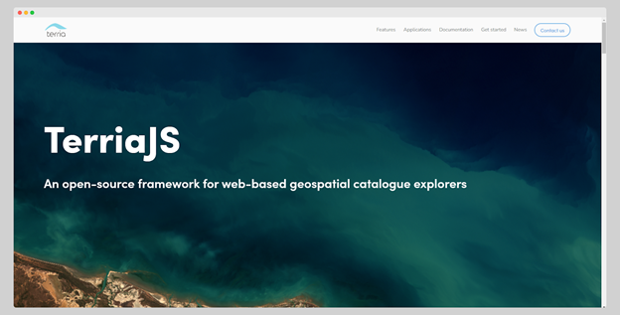
Figure 1: The homepage of the TerriaJS framework (refernce or website).
3.1.1 Data Sources Integration
The platform integrates various data sources, including:
- Satellite Imagery: Sourced from Google Earth Engine and AWS open data registries.
- Numerical Model Outputs: Provides real-time predictions and simulations of the basin’s hydrology.
- In-Situ Data: Sensor data collected across the basin, offering ground-truth validation for the satellite and model data.
3.2 Key Features and Functionalities
The portal's features were developed based on Phase One feedback and inspiration from platforms like Digital Earth Africa. Key functionalities include:
- Data Visualization: Enhanced 2D and 3D visualization capabilities.
- Data Synchronization: Real-time synchronization with data sources.
- Layer Control: A robust layer management panel categorized by thematic areas.
- Interactive Tools: Map export, sharing options, and a time series slider.
- Search Functionality: A geocoding search bar with study area restrictions.
- Data Catalogue: A comprehensive catalogue for data exploration and selection.
Other Functionalities of the Portal are below:
3.2.1 Interactive Map Controls
- Zoom and Pan: Standard map controls that allow users to navigate the spatial datasets intuitively.
- Layer Control Panel: Enables users to toggle different thematic layers on and off, facilitating targeted data analysis.
3.2.2 Data Visualization Tools
- Time Series Analysis: Users can explore temporal changes in the datasets, such as changes in water levels or land use over time.
- Customizable Basemaps: A selection of basemaps is available, allowing users to view the data against different background maps.
3.2.3 Data Export and Sharing
- Map Export: Users can export the current map view as an image file, including any selected data layers and annotations.
- Sharing Capability: The portal supports generating shareable links, enabling users to share specific views or data configurations with colleagues.
3.2.4 AI-Driven Chatbot
An AI-driven Chatbot has been integrated to assist users with queries and navigation within the portal.
3.3 User Experience and Interface Design
The portal's user interface (UI) is designed to be intuitive, with a focus on simplicity and accessibility. The design mirrors that of the DE Africa platform and National Map, with enhancements to better serve the specific requirements of IWMI and the Limpopo River basin project.
3.3.1 Accessibility Features
- Cross-Browser Compatibility: The platform is compatible with all major browsers, ensuring a consistent experience across different devices.
- Responsive Design: The UI is fully responsive, adapting to various screen sizes, including tablets and mobile devices.
3.4 Navigating the Limpopo WebGIS Portal
3.4.1 The Limpopo WebGIS Portal Homepage
Upon accessing the portal, users encounter a welcoming homepage with options to navigate through the platform’s features:
3.4.1.1 Let's Get You Started
- Getting Started with the Map: A video prompt to guide users to navigate and explore the webGIS portal.
- Take the Tour: An interactive guide that walks users through the platform's features and functionalities.
- I'll Need Some Help: A help guide for users who require assistance with navigating the platform or using specific tools.
- Explore Map Data: Begin data exploration directly.
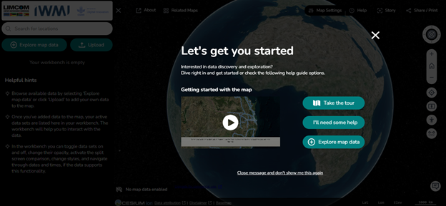
Figure 2: Homepage of the WebGIS portal
3.4.1.2. Search for Location
A search bar, placed at the top left corner of the homepage, allows users to quickly search for specific locations within the Limpopo River basin.
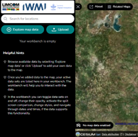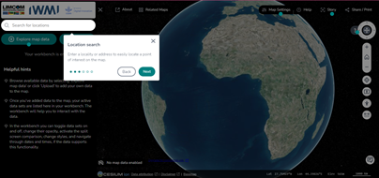
Figure 3: Search location tool.
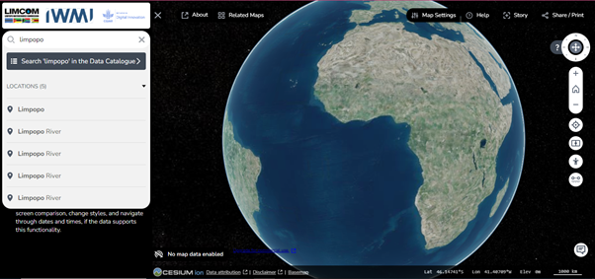
Figure 4: Geocoded location in the Limpopo River basin.
3.4.2. Explore Map Data
Users can select the "Explore Map Data" option to access and interact with available datasets. The “Explore Map Data” feature enables data to be added to the map, also multiple datasets can be added at once and managed through the Workbench.
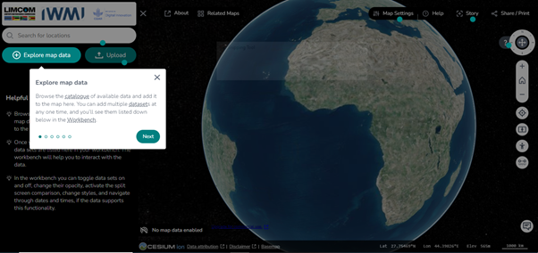
Figure 5: Featuring the “Explore map data” tool
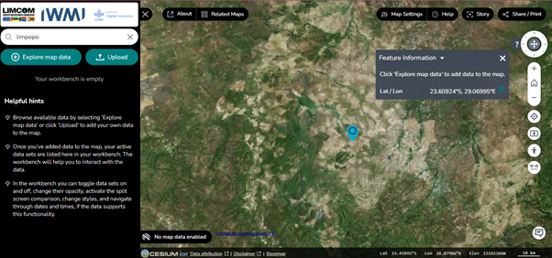
Figure 6: Portal Main Interface
3.4.2.1 Data Catalogue
The Data Catalogue is organized into several thematic categories, each containing relevant datasets for the Limpopo River basin. These categories include Natural Basin Characteristics, Socio-Economic Profile, Water Resources, Ecosystems, and Satellite Images.
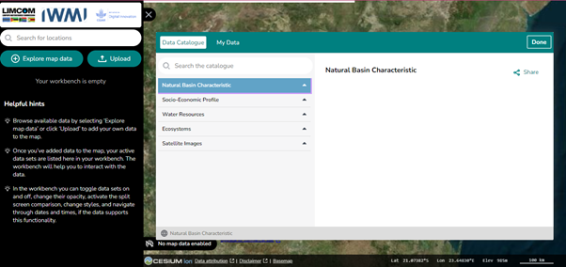
Figure 13: Data Catalogue featuring the thematic layers
3.4.2.1.1 Searching the Catalogue
Users can search for specific datasets within the catalogue using the Search the Catalogue feature. This search function allows for quick access to data of interest, enhancing the user’s ability to find relevant information efficiently.
3.4.2.1.2 Previewing and Adding Data
When a dataset is selected, a Data Preview section appears, offering a brief description of the dataset and the option to add it to the map. For example, selecting "Soil maps" under the "Natural Basin Characteristic" category provides detailed information about the soil types within the Limpopo Basin.
This information includes:
i. Dataset Description: The description outlines the significance of the dataset, including its relevance to sustainable land management and conservation efforts.
ii. Add to the Map: Users can click this option to visualize the dataset directly on the map.
iii. Service Contact: Contact information for further inquiries about the dataset.
iv. GetCapabilities URL: A URL for integrating the dataset into other GIS software.
v. DOI and Data Source: Information about the dataset’s source, including a DOI for citation and the primary data provider.
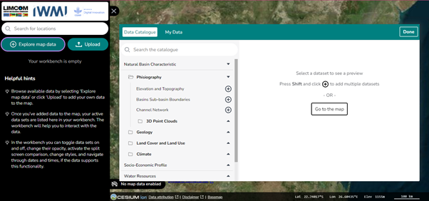
Figure 14: Adding dataset to the map view page

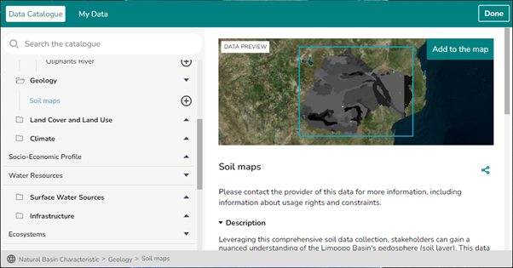
Figure 21: displaying the preview of the "Soil maps" dataset with options to add it to the map and detailed descriptions.
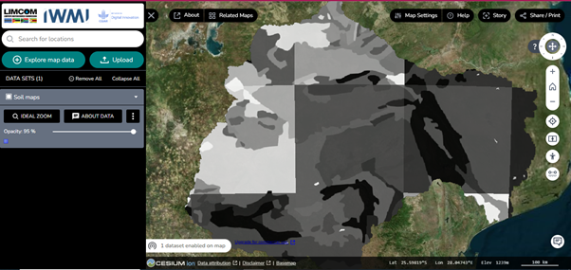
Figure 22: Displayed/added soil maps of the geology dataset.
The About Data icon returns users to the data catalog page and shows the information about the displayed data.
- Natural Basin Characteristic dataset: A click on the dropdown of this feature opens the following datasets:
- Physiography: This displays the listed data which include, elevation and topography, basins sub-basins boundaries, channel network, and 3D point clouds data on the map interface.
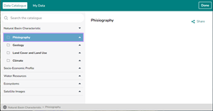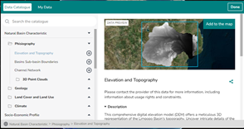
Figure 14: Exploring the Natural Basin Characteristic Datasets
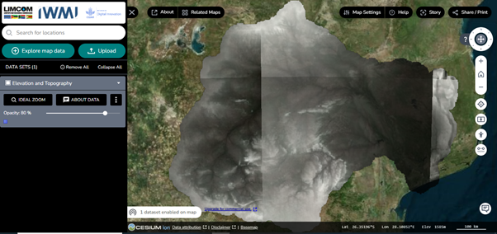
Figure 15: Display of the Elevation and Topography data on the map view page
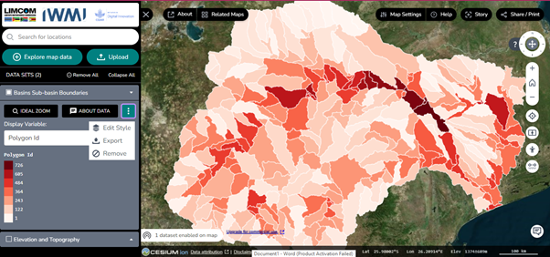
Figure 16: Display of the Basins' Sub-basin Boundaries data on the map view page
Graphics description
The image illustrates the Basins' Sub-basin Boundaries. Key features include:
- Dropdown Menu: Allows users to display dataset features such as Ideal Zoom, data details, and display variables.
- Three-Dot Icon: Provides options to edit the dataset's style, export the map, or remove the dataset from the map view and workbench.
- Vertical Icons: Positioned on the right side of the map, these icons offer descriptions of their functions when hovered over. They assist users in navigating and exploring the map effectively.
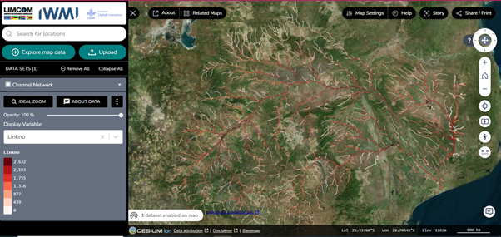
Figure 17: A display of the channel network data of the Limpopo basin area
The display variable allows users to explore charts and filtering of the data.
- 3D Point Clouds: This category contains high-resolution 3D point cloud data for river systems in South Africa, currently including the Oliphants River and the Crocodile River System (Upper & Lower). Collected using Drone surveys, this data provides a detailed and accurate representation of the river topography, enabling specialists to analyze river morphology, model floodplains, map habitats, and monitor changes in the rivers over time.
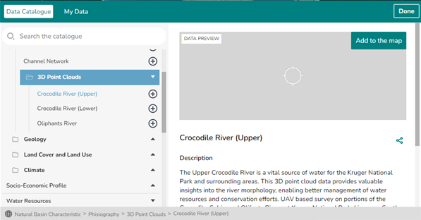
Figure 18: 3D Point Clouds dataset previewed
Graphics Description
On this page, users can click on the desired dataset to preview data and add it to the map. Beneath the data preview is the detailed description and other information about the selected data.
Land Cover and Land Use dataset: This displays the Land Use, Irrigated Mapping, and Vegetation Condition Index (VCI) datasets
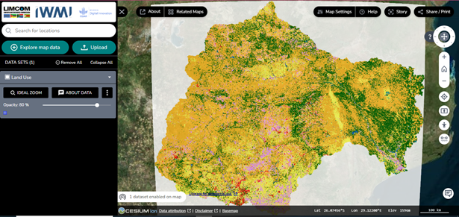
Figure 23: Land use data from the land cover and land use dataset
Some datasets offer advanced features:
- Time Series: For datasets like irrigated mapping, users can explore different time periods using time series controls located beneath the map view and in the workbench panel. Right and left arrows allow navigation through different times.
- Map Styles: Users can change and customize map styles as needed, providing flexibility in data visualization.
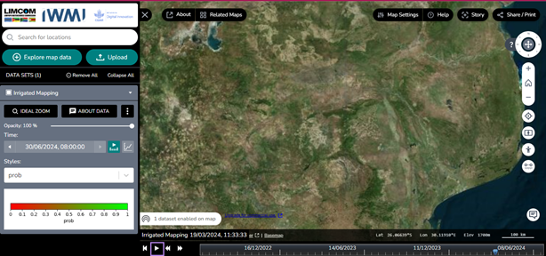
Figure 24: Styling and edit tools of the integrated mapping data displayed on the portal’s workbench
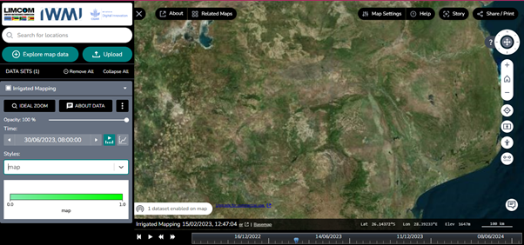
Figure 25: Exploring the properties and editing tools of the integrated mapping data on the workbench
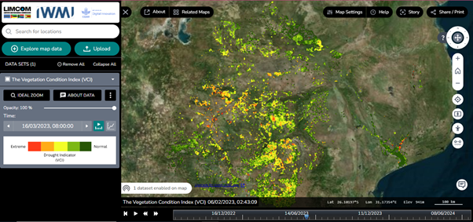
Figure 26: Time series map for the vegetation condition index.
Climate: This catalog contains the following data, CHIRPS Historical Rainfall, Rainfall Monitoring and Forecast, and Rainfall Anomaly Circle Charts.
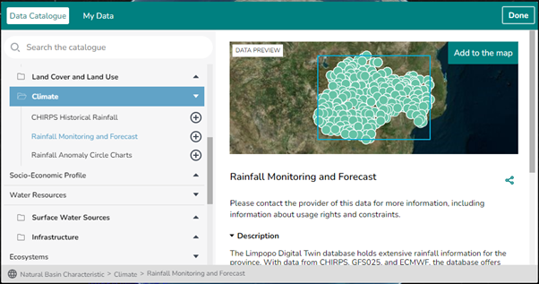
Figure 27: Previewed climate dataset on the data catalogue page
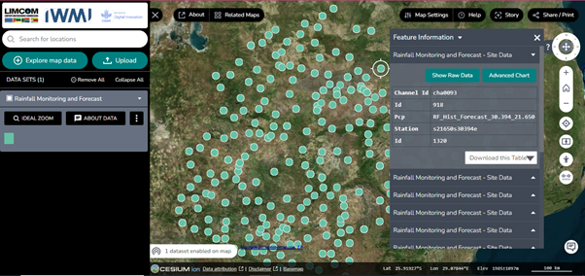
Figure 28: Exploring the Rainfall Monitoring and Forecast Data
Users can click on the data to have more information about each feature of the data. Also show the raw data and advanced chart of the data.
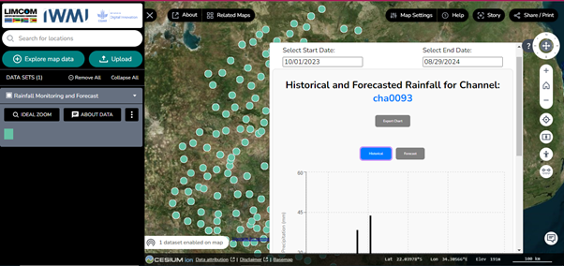
Figure 29: Historical and forecast data of the explored data
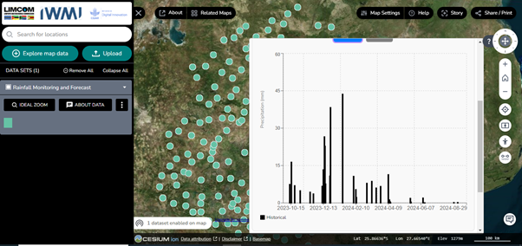Figure 30: A display of the historical data chart
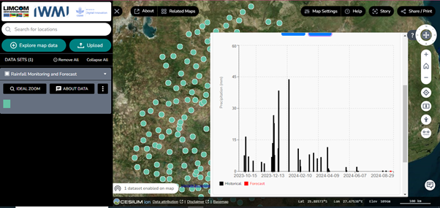Figure 31: Historical and forecast data chart.
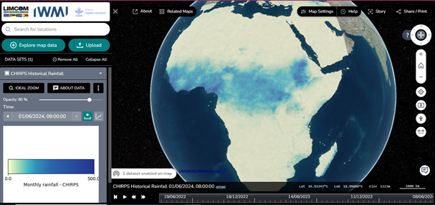
Figure 32: Global time series monthly rainfall – CHIRPS data
Socio-Economic Profile: This contains a dataset on the socio-economic conditions within the basin, including population, and other demographic factors.
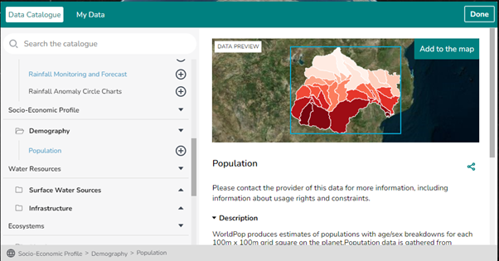
Figure 34: socioeconomic profile dataset featuring population data preview.

Click on data preview to preview the map
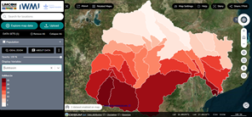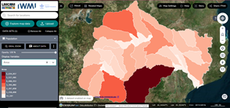
Figure 35: population data on the map view page based on the selected displayed variable
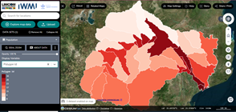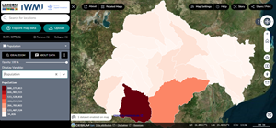
Figure 36: population data on the map view page based on the selected displayed variable
The demographic dataset can be displayed or styled with the options available in the display feature. Users can click on the display dropdown to disable style or style by sub-basin, area, polygon ID, or population.
Water Resources: Datasets about the availability, distribution, and usage of water resources in the region. These datasets include,
- Surface Water Sources
- Infrastructure
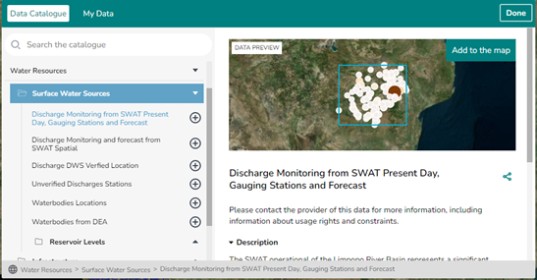
Figure 37: Previewed “discharge monitoring from SWAT present day, gauging stations and forecast” data
Users can explore other data in the dataset as deem fit using the same procedure of data display for other datasets.
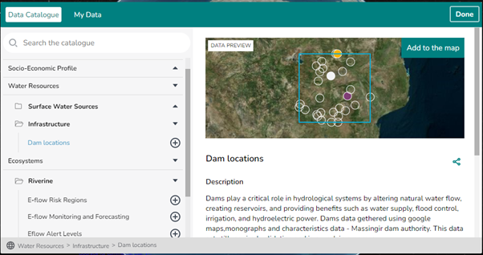
Figure 38: Previewed “dam location” infrastructure data from the surface water sources dataset
Ecosystems: This category includes datasets related to the Limpopo River basin's ecosystems:
- E-flow Regions: Data showing various ecological flow regions.
- E-flow Monitoring and Forecasting: Information on current and forecasted ecological flows.
- E-flow Alert Levels: Data indicating different levels of ecological flow alerts.
- SWAT Incremental Contributions: Details on incremental contributions from the SWAT model.
- E-flow Warnings: Alerts related to ecological flow conditions.
Users can explore and preview each dataset as needed.
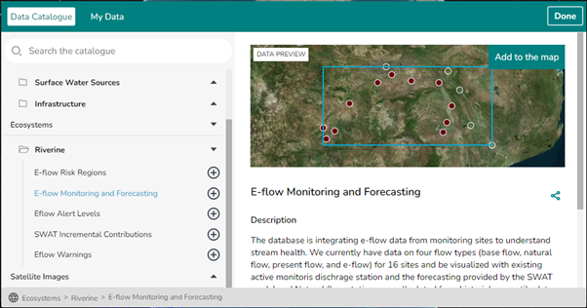
Figure 39: E-flow monitoring and forecasting data previewed from the Ecosystems datasets
Satellite Images: Access to satellite imagery data for remote sensing and environmental monitoring. The data include, Rolling Monthly GeoMAD (Sentinel-2) and Water Observations from Space all-time summary.
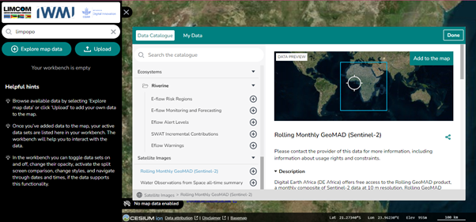
Figure 40: Rolling Monthly GeoMAD (Sentinel-2) imagery/data from the Satellite images dataset
3.4.2.1.3 Navigating the Data
Once a dataset is added to the map, it appears in the Workbench for further manipulation. Users can adjust the visibility, opacity, and compare different datasets using the available tools. The platform supports both 2D and 3D visualizations, depending on the dataset’s nature and the user’s requirements.
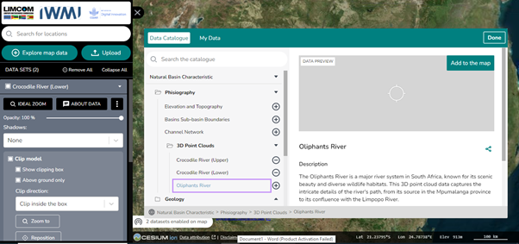Figure 41: Workbench and data preview of the selected data
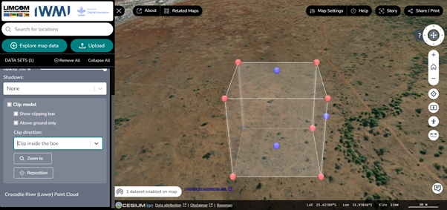
Figure 42: Display of the clip model feature of the explored data
Graphics Description
The 3D point data includes advanced tools:
- Shadows: Options for casting only, receiving only, or both casting and receiving shadows.
- Clip Model: A feature that allows users to clip data inside or outside a box, zoom into the box, and reposition it.
3.4.2.1.4 The Feature Information icon: This section provides details about specific data points on the map. This feature allows users to access and export detailed information about specific locations directly from the map.
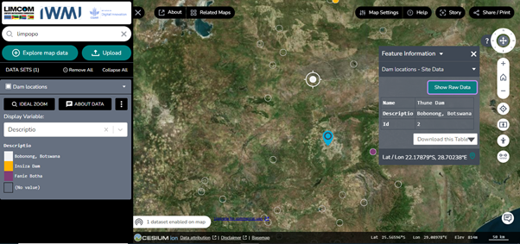
Figure 43: Feature information of explored dam locations dataset displayed
Graphics description
Dam Locations - Site Data: Displays information about specific dam sites.
Data Download Options: Users can download the data table in CSV or JSON formats.
Show Raw Data: An option to view the unprocessed data.
The display variable on the data workbench enables users to style and customize data.
To further edit style, users can click on the 3 dot icon to access the edit style icon and click done after edit.
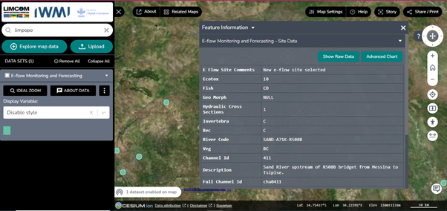Figure 44: Exploring the features of the E-flow Monitoring and Forecasting dataset
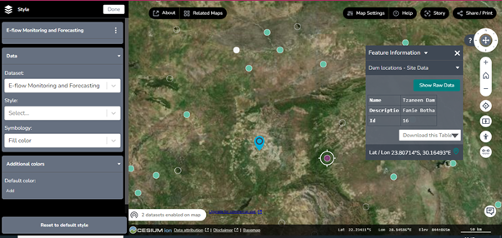
Figure 45: Styling of the E-Flow Monitoring and Forecasting dataset
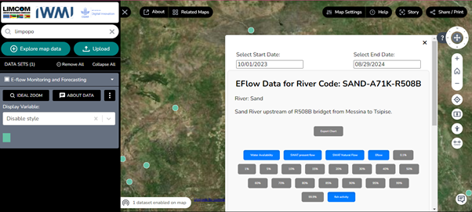
Figure 46: Chart display of the E-flow Monitoring and Forecasting dataset, showing selected start and end date
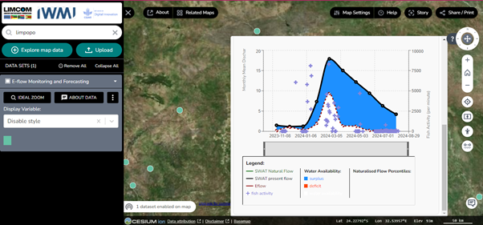
Figure 47: Graph/chart of the E-flow Monitoring and Forecasting dataset
Graphics Description
Hovering over point data on the curve line in the chart provides detailed information about the data. This interaction helps users understand specific data values and their implications directly from the chart.

The attributes include:
- Availability Surplus: The amount or unit of surplus available.
- Deficit: The shortfall or lack of data.
- SWAT Present Flow: The flow data from the SWAT model.
- E-Flow: The environmental flow data.
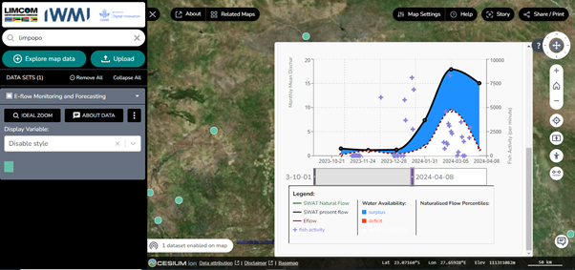
Figure 48: The data graph adjusted based on the time-series feature in the chart.
3.4.2.2 “My Data” Feature Overview
The “My Data” section can be accessed using the “Upload” icon as well as from the “Explore map data” page on the webGIS portal. This feature allows users to integrate their own datasets into the map for localized analysis and visualization. This feature is particularly useful for users who have custom datasets that they want to explore within the context of the Limpopo River basin. The My Data interface offers two primary options for adding data: Local Data and Web Data.
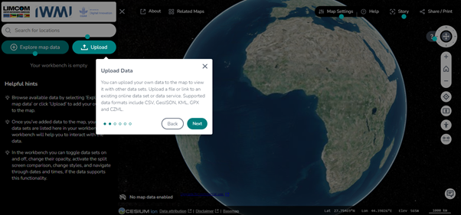
Figure 49: Description of the “Upload Data” feature
3.4.2.2.1 Adding Local Data
Users can easily add their own data files to the map by dragging and dropping them into the My Data section. This functionality is designed for quick and simple visualization of local datasets, without the need to upload or save them to the cloud. This feature supports various file formats commonly used in geospatial analysis, such as:
- GeoTIFF
- Shapefiles
- KML/KMZ
- GeoJSON
- CSV with location coordinates
Once a file is dropped into the area labeled "Drag and drop a file here to view it locally on the map," the platform will render the data on the map for immediate interaction.
Steps to Add Local Data:
- Drag and Drop: Drag the file from your local storage and drop it into the designated area.
- View on Map: The platform will automatically render the data, allowing you to view and interact with it directly on the map.
- Manipulate Data: Use the Workbench tools to toggle visibility, adjust opacity, and compare your dataset with other layers.
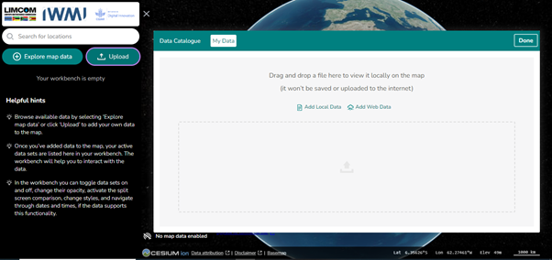
Figure 50: showing the drag-and-drop area in the My Data section where users can add local files to the map.
3.4.2.2.2. Adding Web Data
In addition to local files, users can also add datasets from external web sources. This is done by selecting the Add Web Data option. Users can input URLs from Web Map Services (WMS), Web Feature Services (WFS), or any other compatible online geospatial data services. This feature allows users to integrate and visualize real-time or external datasets alongside the platform's existing data catalog.
Steps to Add Web Data:
- Select Add Web Data: Click the Add Web Data button.
- Enter URL: Input the URL of the web service or data source.
- Visualize Data: The platform fetches the data from the URL and displays it on the map.
3.4.2.2.3 Benefits of the My Data Section
- Flexibility: Users can visualize their datasets without the need to upload or store them on the platform.
- Privacy: Data added via the My Data section is not uploaded or saved to the internet, ensuring that sensitive information remains secure.
- Integration: The ability to add both local and web data allows for comprehensive analysis by combining user-specific data with the platform’s rich dataset catalog.
3.4.3 Workbench
The "Workbench" is a key feature for managing active datasets within the WebGIS portal. It provides users with the following functionalities:
- Toggle Data Sets: Turn datasets on or off as needed.
- Adjust Opacity: Modify the transparency of datasets.
- Compare Data: Use split screen mode to compare datasets side by side.
- Temporal Navigation: Access and navigate through time series data, if available.
- Manage Data:
- Remove All: Clear all datasets using the Remove All icon.
- Collapse All: Minimize all datasets for a cleaner view.
- Individual Datasets: Remove a specific dataset by clicking the 3-dot icon.
- Data Toggle: Use checkboxes to turn datasets on or off.
- Data Details: Use the dropdown next to each dataset to zoom, adjust opacity, and view details. The Ideal zoom feature optimizes the view of the dataset
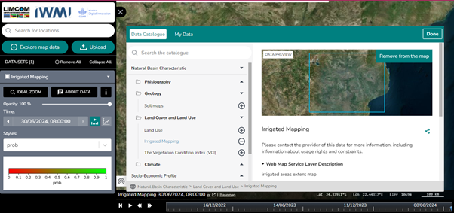
Figure 51: Workbench displayed on the left side of the map
3.4.4. About Page Overview
The About icon on the platform opens a new browser window that provides users with information about the Limpopo Digital Twin Concept and its connection to the NationalMap platform. It explains the platform's purpose, its open data architecture, and offers guidelines for using and contributing to the map. The page also covers software details, terms of use, and legal disclaimers, ensuring users understand the data's limitations and how to access further support.

3.4.5 Related Maps Feature
The Related Maps icon directs users to a page where they can access and explore similar maps from other platforms, such as NationalMap and Digital Twin Victoria. This feature helps users broaden their perspective by connecting to additional geospatial resources.
- Navigation: Clicking on a map opens a new window or tab, taking users to the selected platform for further exploration.
- Comparison and Exploration: Allows users to view and assess maps from different sources for enhanced spatial analysis.
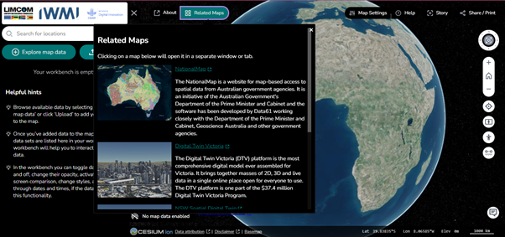
Figure 52: The “Related Maps” feature.

3.4.6 The Help feature
The Help feature of the WebGIS Portal is designed to provide users with comprehensive guidance and support for utilizing the platform effectively. It offers various resources and tools to assist users in navigating and making the most of the WebGIS Portal's functionalities.
It includes a variety of resources such as:
- Guides and Contact: Users can access guides or contact the support team at iwmigeospatial@gmail.com for help.
- Take the Tour: A guided tour for new users. This enables new users to navigate each feature on the portal while describing the functionalities of each feature. Click on “start tour” to begin.
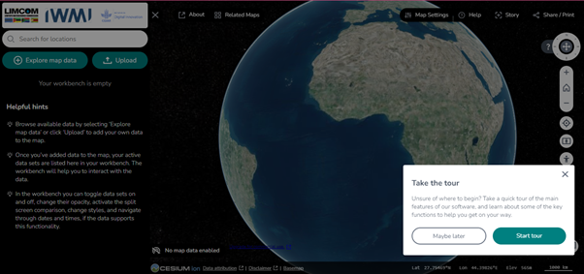
Figure 53: The tour guide navigation feature.
- Getting Started with the Map: A video and instructions covering basic map functionality, such as searching for locations, exploring data sets, interacting with data layers, and changing the base map.
- Step-by-Step Guides: Detailed instructions for various workflows.
- Share & Story Migration: A guide on updating share links from older versions of TerriaJS.
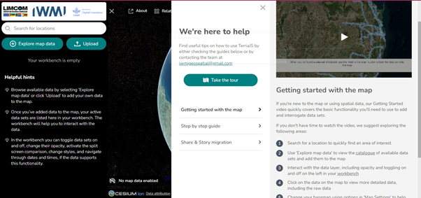
Figure 54: Exploring the “Help” feature of the webGIS portal
3.4.7 The Story feature
This feature in the WebGIS Portal enables users to create and share compelling narratives by capturing and presenting geospatial data in a structured format. This feature is designed to help users tell their stories effectively by leveraging the visual and interactive capabilities of the portal.
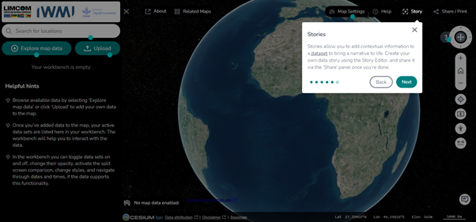
Figure 54: Description of the story tool for creating informative narratives.
Users can create and share stories that highlight specific aspects of the data, including adding narrative and visual elements to enhance data presentation.
3.4.7.1 Story Feature Components
Story Editor: The Story Editor is the primary interface where users can create and manage their stories. It provides tools for integrating maps, data layers, and narrative text into a coordinated presentation. Users can create and share stories that highlight specific aspects of the data, including adding narrative and visual elements to enhance data presentation.
3.4.7.2 Getting Started: The “Getting Started” tab directs users to a YouTube video created by Terria that covers the basics of data stories. This video provides a visual and practical introduction to creating and using the story tool within the portal. In addition to the video, users have access to a getting started guide developed by Terria. This guide includes detailed instructions on how to use the Story Editor, capture scenes, and incorporate various elements into their stories.
3.4.7.3 Capture Scene: To start storytelling, users can click the “Capture Scene” icon. This opens a pop-up where users can enter a project title and a detailed description, similar to a Microsoft Word interface. Once completed, users click "Save" to save their work.
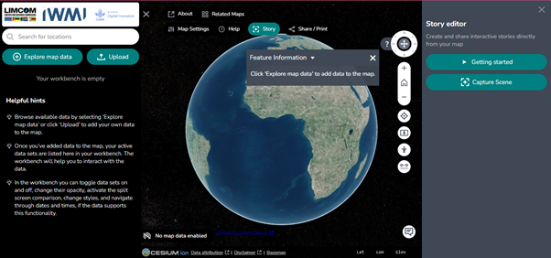
Figure 54: Story tool interface on the WebGIS portal.
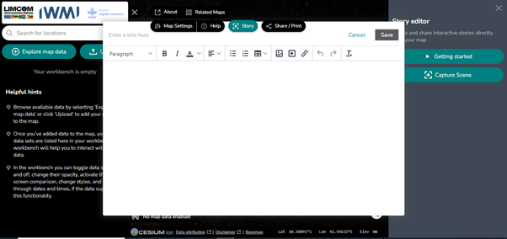
Figure 55: Creating a story for a project using the capture scene tool in the story editor
3.4.8. Share/Print Feature
The Share/Print feature allows users to:
- Share: Generate a URL to share the project.
- Download: Save the map as a PNG image.
- Print: View and print the map.
3.4.8.1 Advanced Options:
- Include Story: Add the story to the shared content.
- Shorten URL: Use a web service to create a shorter shareable link.
To access these options, click on the "Advanced Options" dropdown.
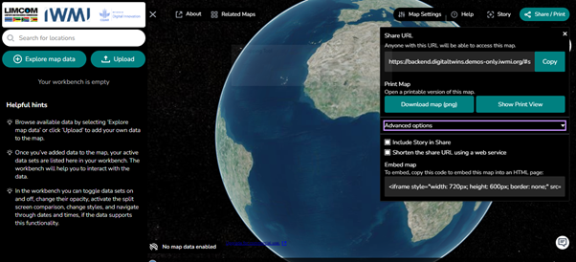
Figure 56: Share/print tool interface for exporting and sharing maps.
3.4.9 View Controls
The View Controls icon, located on the right side of the map view and resembling a ring with a cross in the middle, offers:
- Orientation: Rotate the map in 360 degrees.
- Reset: Restore the default map orientation.
Additional icons beneath this control facilitate easy map navigation and management, these include;
- Home Icon: Returns the map to the default globe view.
- + Icon: Zooms in on the map.
- – Icon: Zooms out from the map.
- Location: Activates live location tracking. Click "Allow" in the popup to enable this feature.
- Pan: Drag the map using the left mouse button.
- Zoom: Adjust zoom levels using the mouse scroll wheel.
- Measure Tool: Allows users to measure distances between points on the map.
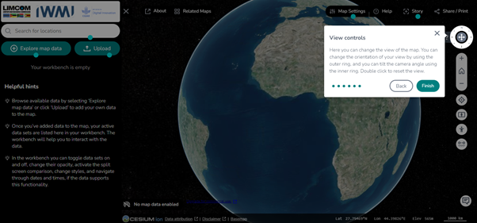
Figure 57: Displaying the “View controls” description tool.
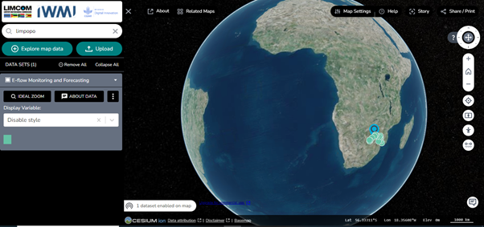
Figure 58: Displaying the globe view of the map using the home icon on the right side of the map.
- Compare Feature: The Compare Feature enables users to view and analyze two datasets side by side using Split Screen Mode. This is ideal for detailed data analysis and comparison.
Here’s how it works:
- Activate Split Screen: Click the Compare Tool to enter Split Screen Mode.
- Select Datasets: Choose the two datasets you wish to compare.
- Adjust View: Use the split bar to resize and align the datasets for optimal comparison.
- Analyze Differences: Compare the datasets visually, identifying differences and similarities.
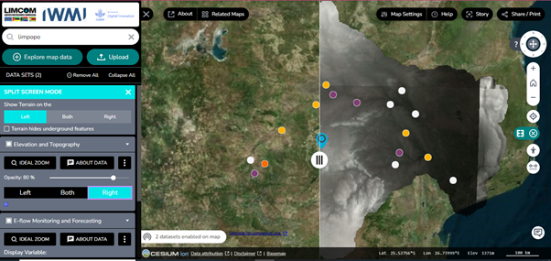
Figure 59: Showcasing the split screen mode tool on the WebGIS portal.
Graphics description
Data Sets: Lists the datasets currently being compared.
Remove All: Option to clear all datasets from the comparison view.
Collapse All: Minimizes the dataset details for a cleaner interface.
Split Screen Mode:
Left: Displays one dataset on the left side of the screen.
Right: Shows the other dataset on the right side.
Both: Presents both datasets on either side for direct comparison.
Terrain Note: Reminds users that terrain layers may obscure underground features, which could be significant depending on the datasets being compared.
- Pedestrian Mode: The Pedestrian Mode Tool provides a street-level view of the data, allowing for detailed exploration of geographic features. Key functionalities include:
- Street View: Offers a ground-level perspective of the data, mimicking a pedestrian's view.
- Control Tool: Used to rotate the imagery for an improved view.
- Keyboard Shortcuts:
I. Space Key: Moves forward.
II. Shift Key: Moves backward.
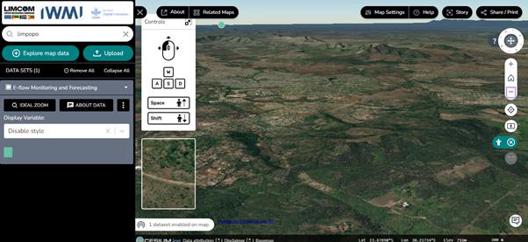
Figure 60: The “pedestrian mode” tool
- Measurement Tool: The Measurement Tool allows users to measure distances between points on the map. Key features include:
- Length Measurement: Enables users to measure the distance between two or more points.
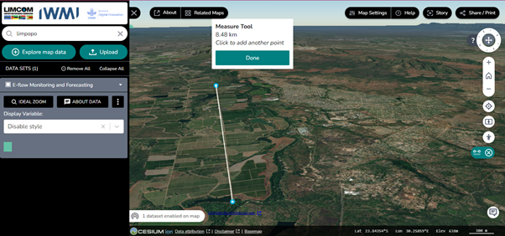
Figure 61: Exploring the measure tool feature
3.4.10. Map Settings: Allows users to customize the map display, including selecting base maps, adjusting data attribution, and managing map quality for improved performance
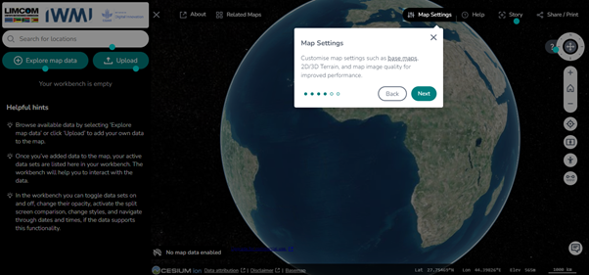
Figure 62: Displaying the description of the map settings from the site tour
The features of the map settings include map view, terrain positioning, base map selection, timeline, image optimization, and map quality.
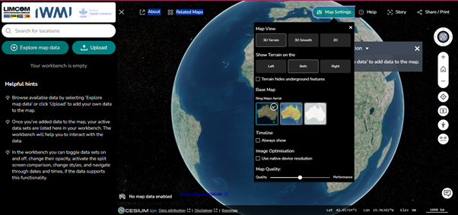
Figure 63: Displaying the map settings feature
3.4.11 The Feedback icon: This is beneath the web portal homepage. The Feedback feature allows users to share their thoughts or ask questions directly with the developers of the Limpopo Digital Twin Concept. This feature is designed to make it easy for users to communicate directly with the platform's developers, helping them improve the tool based on user experience.
Here's what users can do:
- Your name (optional): Users can enter their name, but it's not required.
- Email address (optional): For the Developer’s team to do a follow-up, users need to provide their email.
- Comment or question: This is where users write their feedback or inquiries.
- Share my map view: Users can choose to share their current map view along with their feedback, giving the developers context for their comments.
- Cancel: Exit the feedback form without sending the message.
- Send: Submit feedback to the developers.
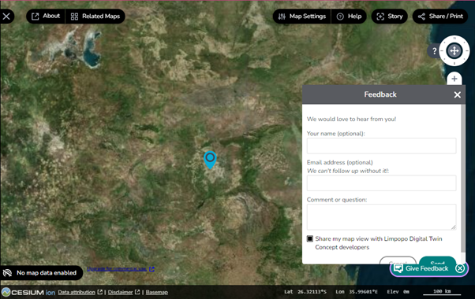
Figure 64: Displaying the feedback feature
3.4.12. Data Attribution and Basemap Selection
At the bottom of the homepage, there are options for data attribution, selecting base maps, and viewing disclaimers related to the data being used.
3.4.13. Version and System Information
- Version: 2024-8-26-0.1.2-8.7.1-aba34780
- Platform Components: Cesium ion for 3D mapping, data attribution, and base map selection.
4. Development Process
4.1 Iterative and Incremental Development
The development of the WebGIS Portal followed an iterative and incremental approach, ensuring continuous enhancements and refinements based on stakeholder feedback. Each development phase focused on integrating new features and improving existing functionalities.
4.1.1 Phase 1: Data Source Identification and Integration
- Data Audit and Classification: Comprehensive audit of existing data sources, categorizing them by type and relevance.
- Prototyping: Early prototypes were developed to test data integration processes.
4.1.2 Phase 2: Implementation and Testing
- Backend Development: Implementation of data ingestion and processing pipelines.
- Frontend Development: Creation of the interactive UI components for data visualization.
- Integration Testing: Rigorous testing to ensure all components function seamlessly together.
4.1.3 Phase 3: Continuous Improvement
- User Feedback Integration: Continuous iteration based on user feedback, with enhancements to both UI and functionality.
- Documentation and Training: Development of user manuals and training sessions for end-users.
5. Deployment and Maintenance
5.1 AWS Deployment
The portal was deployed on AWS, leveraging its scalable infrastructure to ensure high availability and performance.
The deployment process included:
- Test Server Configuration: Initial setup and testing were conducted on a dedicated test server.
- Production Server Migration: Upon successful testing, the portal was migrated to a production environment.

5.2 Maintenance and Support
Ongoing maintenance is planned to address any issues that arise post-deployment. This includes:
- Bug Fixes and Updates: Regular updates will be applied to address any bugs and incorporate new features.
- User Support: A support channel has been established to assist users with any queries or issues.
6. Conclusion
The development of the WebGIS Portal showcasing the Digital Twin (DT) for the Limpopo River basin represents a significant advancement in geospatial data visualization for IWMI. The portal, built on the robust TerriaJS framework, integrates diverse datasets and offers powerful tools for data exploration and analysis. This project not only enhances IWMI's capacity to monitor and manage the Limpopo River basin but also sets a precedent for future geospatial initiatives.

